**Yorkshire Trios – Feedback From Professional Development Programme**

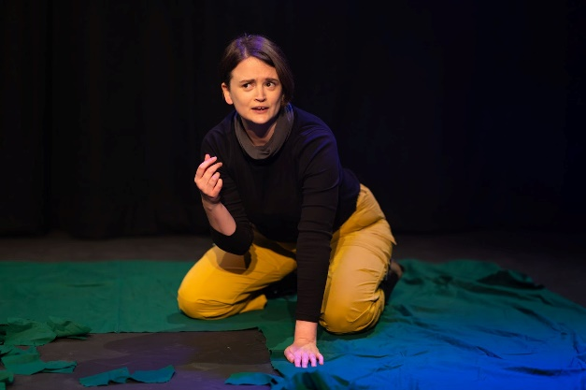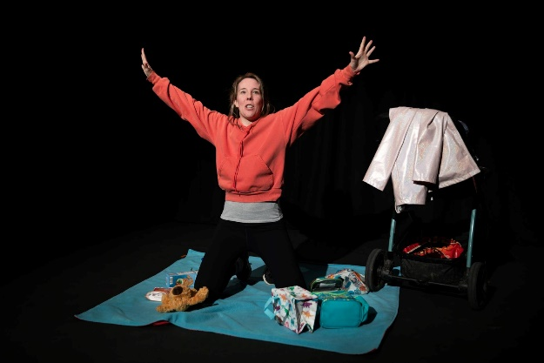

ABOUT

We recruited and selected the 13 local creatives who received mico-commissions as part of Yorkshire Trios. We had 4 times the amount of applications as we did commissions available. We held an induction session, received first drafts from writers and provided feedback for their second drafts. They were then supported to work on these as trios, producing a short performance for a showcase of work at York Theatre Royal at the end of March 2024.

An article explaining more about Yorkshire Trios was published by [Charles Hutch Press](https://charleshutchpress.co.uk/yorkshire-trios-confirmed-for-next-door-but-ones-theatrical-showcase-at-york-theatre-royal-studio-next-march-whos-taking-part/)

RECRUITMENT

At recruitment stage here were two points to note:

* Diversity: We had a real diversity in application and appointment, specifically in the areas of gender, sexual orientation, disability and caring responsibilities. From those in receipt of commissions, 23% are disabled, 23% LGBTQ+, 54% women, 31% have caring responsibilities, 8% Global Majority.
* Flexible Opportunities: We have taken on an additional creative, who applied for the role of Director, but did not have quite enough experience to lead on any of the scripts, so we created an assistant director role so that she could develop in the way she was hoping (learning from female creatives with more experience than her). In addition to this, a Chinese playwright, new to York who is wanting to build his network and understand how his writing transposes to UK stages, is being provided with additional mentoring to help him in this transition and development.

Feedback within recruitment and early stages of the project included:

* *‘Working with this group of amazing people in York gives me a chance to take a glance into the local theatre industry and help establish myself as a playwright here.’*
* *‘I wanted to get involved with Yorkshire Trios because there is a lot of local talent in York and this is a perfect opportunity to widen my creative circle. I cannot wait to work so closely with a writer and director. It is such a rarity to have a 1-1 experience in the rehearsal room and so I’m excited to collaborate together, creating beautiful theatre, fuelled with passion. Next Door But One have a fantastic support system and I’m looking forward to being mentored and learning more about the process of creating a play, from outside the eyes of an Actor.’*
* *‘Having heard from friends what an incredible and inclusive company NDB1 was to work with, I was eager for the opportunity and chuffed to bits to be cast in Yorkshire Trios. As an autistic full time working parent, finding flexible inclusive work can be a challenge and being welcomed with open arms, kindness and understanding by the whole NDB1 team has been lovely. Meeting my Yorkshire quartet, such a talented creative and passionate bunch of local folks……I cannot wait to see our piece grow and develop, to be really challenged as an actor and to make some more meaningful connections here in York!’*
* *‘Yorkshire Trios has given me an opportunity to explore my own voice within writing, something I have had little time for since becoming a mum. Being a creative is incredibly rewarding but also at times lonely. After an initial meeting with NDB1 and the other Trios, I already feel more connected and part of an exciting community of Yorkshire-based creatives.’*

PERFORMANCE AND EVALUATION

Yorkshire Trios concluded with 2 sellout performances at York Theatre Royal. The artists involved were extremely pleased and proud with the end product, and the audience were full of praise for the performances, many staying afterwards to talk about the content and process. A recurring piece of feedback from the audience was that Yorkshire Trios is ‘exactly what the city needs, both for original theatre and to support the local talent’. Evaluating the whole project with the Trios themselves:

* 90% made a new network and had the opportunity to collaborate in new ways with other artists.
* 90% ‘brushed up’ on existing skills and developed new ones
* 70% got the opportunity to present their work in York for the first time.
* 60% felt this gave them a chance to be creative in a way that felt true to their own practice.
* 30% now have a new or developed idea to expand on in the future.

Feedback was extremely complimentary for the NDB1 support, values and ethos.

* *‘Working with NDB1 was amazing. This can't be said enough. The support, care alongside truly being empowered to make the project what it needed to be was wonderful.’*
* *‘The care and support that NDB1 provide is unmatched to anyone else I’ve ever worked with. The wellbeing support is rare to have in companies, yet so great to know there was always someone to talk to. Also, the feedback was always insightful, honest and warm. NDB1 are so organised, provided space for us to rehearse and gave plenty of notice for anything that was required from ourselves throughout the process. Honestly, cannot rave about NBD1 enough!’*
* *‘NDB1 are a delightful company to work with. They create an environment that is supportive, inclusive and creative. They truly enabled all the trios to bring their best selves to their work and created an event that everyone involved can be really proud of.’*

And to summarise the impact, a Trios member said:

* *‘Just want to take this moment to say a massive thank you. This type of theatre is rare to find, especially as an artist and I’m super grateful for the opportunity. I have loved the entire process and it has allowed me to develop my craft further whilst telling a beautiful story that is under represented within theatre. I have felt so supported throughout the entire process and I really hope NDB1 can do this for years to come - it’s truly an ace experience that is vital to building artists careers.’*